Handout “ Unit Education and lifelong Learning”
Reading Activities

Name: …………………………………………. Grade: 1st ……………… Date: ……………………………….

O.A. : Demostrar comprensión de ideas generales e información explícita en textos adaptados y auténticos simples
Instructions:
- Finish the assessment in two hours.
- Read the instructions carefully.
- Work in groups or individually.

In Unit 2, Keep on learning, the main topic of education has been linked to other significant themes: learning improvement, technological learning resources, gender equality in education, importance of physical education, school problems, advantages of studying English, all of them meaningful topics in students’ lives.

Recuerda:
Cuando leas las instrucciones o el texto dado , intenta leer sin traducir, saca la idea general (Tú puedes), si necesitas traducir alguna palabra o frase subraya la palabra y anota su significado. Lee cuidadosamente.

1. Do the following quiz and find your learning style. Then, share your results in your group and comment on them.

Circle the best answer for each question.
Answers will vary
1. If I have to learn how to do something, I learn best when I:
a. watch someone to show me how.
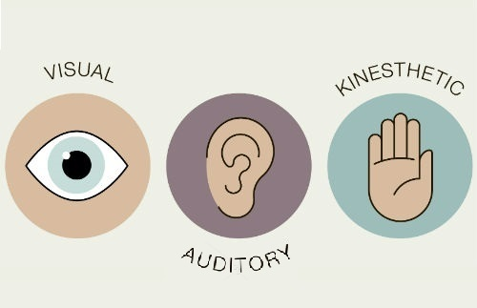
b. hear someone tell me how.
c. try to do it myself.

2. When I spell, I verify accuracy by:
a. looking at the word to see if it looks correct.
b. sounding the word out in my head.
c. getting a feeling about the correctness of the spelling.

3. When asked to give directions, I:
a. see the actual places in my mind as I say them or prefer to draw them.
b. have no difficulty giving them verbally.
c. have to point or move my body as I give them.

4. When I have to remember a list of items, I remember them best if I:
a. write them down.
b. repeat them over and over to myself.
c. move around and use my fi ngers to name each item.

5. When solving a problem, I:
a. write or draw diagrams to see it.
b. talk myself through it.
c. use and/or move objects to help me think.

6. When I am adding numbers, I verify my answer by:
a. looking at the numbers to see if they are correct.
b. counting the numbers in my head or out loud.
c. using my fingers to get a feeling if it is correct.
7. When trying to recall names, I remember:
a. Faces more easily than names.
b. Names more easily than faces.
c. The situation or the meeting more easily than names or faces.

8. Before going to sleep at night, I appreciate that:
a. The room is dark.
b. The room is quiet.
c. The bed feels comfortable.

Results:

Write in how many of your answers was each of the following letter choices:

a: ……………………………. b:………………………………. c:……………………………..

Interpretation:

If you had mostly a’s, then you are a visual learner.

• Sit in the front of the class or meeting so you can see everything.
• Sketch course content. Even the simplest sketch can help you remember ideas.
• List your tasks – even the ones you have completed – just to have the satisfaction of visually crossing out tasks done.
• Write notes on your favorite colored sticky-notes to help you remember and paste them around your room.
• A tidy desk may help in clearing your mind to be able to study better.
• Write yourself encouraging notes and post them where you can see them.
• Create mind maps, flowcharts, or other graphic organizers.

If you had mostly b’s, then you are an auditory learner.

• Record the class session and listen to it later for reference and repetition. It may also help if you listen to it casually while walking to class or before falling asleep.
• Read your textbook and notes aloud as you study. You could even record them as you do so.
• Teach yourself to read aloud in your mind without making sound. During exams, you can hear the test questions as well as see them.
• Study with a partner or in a group. When studying with others, you can hear what they say, and hear yourself teaching them as well. This will reinforce your understanding of the material.
• Proofread your assignments out loud.

If you had mostly c’s, then you are a kinesthetic learner.

• Sit where you can actively participate in classroom events and discussions.
• Take notes creatively. For instance, draw quick pictures in class that relates to the material being taught.
• Ask and answer questions before, during, and after class.
• Make models of the concepts whenever possible.
• Move around while you are studying. For instance, you can simply walk around in your room.
• Study on a whiteboard. Draw flowcharts, mind maps, or simply rewrite the notes.
• Incorporate pictures of models, if possible.
• Make physical comfort a priority as you study.
• Make note cards and create sample tests that you can take for review.

2. Underline three learning tips you found useful in the interpretation section of the quiz. Then, write down two more tips of your own.
______________________________________________________________________________________ Answers will vary
_____________________________________________________________________________________________________________________________________________________________
3. What strategies have you used for studying?
____________ Answers will vary
_______________________________________________________________________________________________________________________________________________________________________________________________________________________________________

3. Fill in the blanks of the emails with the words in the box below. Then, match the problems at school (a - c) with their solutions (1-3).

stressed out a couple of months laugh at cost a lot of money schoolwork cruel messages shy and nervous where to start cannot afford it panic at to help them bullied

a.
Casey, 14
Well… I´m constantly being _____BULLIED_____________at school. My classmates _____LAUGH AT__________________ me a lot and call me names because I´m new at school and because I´m a foreigner. Recently it has got even worse; they have been posting ____CRUEL MESSAGES___________________ on Facebook…What´s worse, I´m very___SHY____________________ and NERVOUS ______ find it really difficult to talk to people… How can I stop this situation?

b.
Zach, 15
Hi there! I need some advice. Our class is planning a field trip to Washington DC and it is going to ____COST A LOT OF MONEY___________________. Most of our parents are happy to help but there are four students whose parents___CANNOT AFFORD IT____________________. We, the whole class, want everybody to go but are not really sure what to do___TO HELP THEM____________________. There´s not much time because the trip is in____A COUPLE OF MONTHS________________ . What can we do to solve this problem?

c.
Ashlee, 15
Hello. I hate____SCHOOLWORK_________! I get so______STRESSED OUT_____ with all the homework and the assignments that I often cry. I do not know__WHERE TO START____ when I´m home on my own. I also______PANIC AT_________________ deadlines… And I even have a hard time sleeping sometimes. I´m so frustrated!
Please, help me!
A. 3 B. 1 C.2
1  It is so good to hear from someone who wants to help a friend. I am glad that you are not thinking of leaving your classmates alone. There are a lot of things you can do to help in two months. You could organize a school Bingo, you could bake cookies and cakes and sell them at school. Or you could also find a sponsor for your friends – a local company willing to pay their fare.  Sarah | 2  Stressing too much about it doesn’t get you anywhere. It’s good to be concerned about your work, but you have to act on that. To avoid trouble, do homework as soon as possible and at least start projects the day you get them. When you start your homework, tackle the hardest assignments first. It’s tempting to start with the easy stuff to get it out of the way, but you’ll have the most energy and focus when you begin, so it’s best to use this mental power on the subjects that are most challenging. Later, when you’re more tired, you can focus on the simpler things. And always, take small breaks to help you relax a little and reduce stress in the end.  Robert
3
First thing, you should immediately tell an adult: a teacher, a principal or your parents about what´s going on. They will help you somehow. This is not right at all. Also, you should firmly and clearly tell the bully to stop and then walk away. By ignoring the bully, you’re showing that you don’t care. Eventually, the bully will probably get bored with trying to bother you.
Megan

Have you had problems with your classmates, your teachers or your Family?
__Answer will vary____________________________________________________

Page 52:
How are you ready?
Exercise 2
Answer
a. Highlighting
b. Note-taking
c. Word map
d. Study plan
Page 53
Preparing to read
Exercise 2
Auditory learners | Kinesthetic learners | Visual learners
- Difficulty with written  directions.  - Prefer to get information by listening | - Prefer hands-on learning.  - Learn better when physical activity is involved. | - Need to see it to  know it.  - Difficulty with spoken directions.

Exercise 3
Possible answer

Auditory: create a rap of what you have to learn; participate in class discussions; make speeches and presentations; use a tape recorder instead of taking notes; read texts out aloud; create musical jingles to aid
memorization; dictate to someone while they write down your thoughts, etc.

Kinesthetic: take frequent study breaks ; move around to learn new things; read while on an exercise bike; mold a piece of clay to learn a new concept; work at a standing position; use bright colors to highlight reading material;
dress up your work space with posters; listen to music and dance while you study, etc.

Visual: use pictures, charts, maps, graphs, etc.; use color to highlight important points in a text; take notes; illustrate your ideas as a picture before writing them down; use multi-media (e.g. computers, videos, and filmstrips)

Page 54
Ejercicio 1
Answer
Study tip 1. - b. Only what’s important
Study tip 2. - e. Making your own study notes
Study tip 3. - d. Associating concepts
Study tip 4. - f. Using images
Study tip 5. - a. A rainfall of ideas
Study tip 6. - g. Getting into the habit
Smart reading
Answer
1. d. To describe.
2. a. Tip 1. b. Tip 2 c. Tip 4. d. Tip 3.

Listening Activity:
- Look at this video:
https://www.youtube.com/watch?v=Dp5QNsKwt2c
- Answer these questions: Answers will vary
- Why English language is important in our life?
________________________________________________________
- How does English class help you in the future?
________________________________________________________
- Would you like to study abroad?
________________________________________________________
- Listen to a recording about studying abroad. What kind of text is it?
(1o Medio - Track 28)

- An advertisement
- News reports
- An interview
- Personal experiences

- Listen to the recording again and number the sentences in the order you hear them. (1o Medio - Track 28)
4 – 5 – 2- 1- 3

- First, I did not speak English very well.
- I started talking a lot.
- I can communicate with them through English.
- Sometimes, I feel sad.
- The school has a good atmosphere.

- Listen again and match the situations in the pictures to each Speaker (1 - 4).
(1o Medio - Track 28)

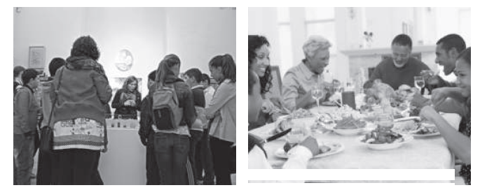
- Speaker ……3………………… b. Speaker ………4…………………

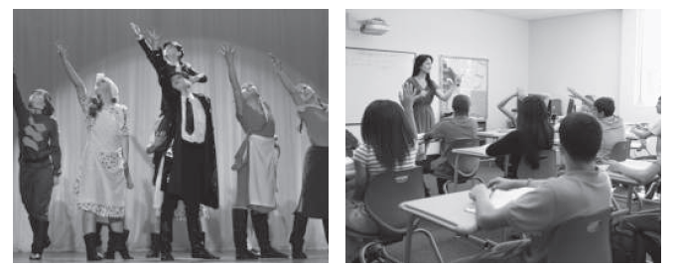
c.Speaker ……1………………………….. d. Speaker ……………2…………………..

6. Listen once more and circle the correct alternative.
(1o Medio - Track 28)

  - I have made a few / lot of friends.
  - There are many activities for teaching / practicing English with fun.
  - I have improved my language / English skills.
  - I stayed for sixteen / six months.
  - My host / new family was very nice, too.

Now, you will work with your English book : “ Teens in Motion 1”
Atención: Se dan las páginas y ejercicios que debes realizar, pero las instrucciones no están traducidas, solo te guío para que puedas realizarlo y conocer tu libro.
Track 22
Page 70
How ready are you?
Exercise 1:
Possible answer
Advantages:
- it is spoken around the world.
- It widens access to information in books and magazines, on the internet, from English-speaking people.
- It increases a person’s education and work opportunities.
- It facilitates communication with foreigners in Chile or abroad, etc.

Disadvantages:
- it is difficult to learn.
- The relationship spelling –pronunciation is complicated.
- There are many words that are very similar but have different meaning.
- Accentuation in words and sentences is important and complicated, etc.

Exercise 2
Possible Answer

- The girl mentions two reasons why learning English is good (both of them could have been mentioned by the class): to understand what you find on computers and to read about business travel and science.

- The boy also mentions two reasons: English is very important in his country (probably it is used as the lingua franca between speakers of different languages) and because it is usually a requirement to get a good job (most students in the class could have mentioned this point).

Page 71
Preparing to listen
Exercise 3
Negative | Neutral | Positive
aggressive, boring, lazy,  nervous, offensive,  rude, shy, tense, upset | blue, long, new,  short, tall, young | Positive  beautiful, excellent,  fresh, kind, pretty,  smart, wonderful

Page 72

Focusing on listening

Exercise 1
Answer
Words mentioned: aggressive, boring, lazy, nervous, offensive, shy, upset, rude.

Exercise 2
Answer
- General information
Type of recording: a telephone helpline program
Speakers : a. teens / counselors

- Specific details
- Problems mentioned in each conversation:
a. II. b. I. c. III.

- Which recording describes…
a. III. b. II. c. I.

- Main conclusions
a. III. b. II. c. I. d. II.

Page 73

After listening
Work it out

Answer
- In each case, the speaker is talking about actions that started in the past, but continue or are related to the present.

Exercises

- Read the text then answer the questions below.

Dear Marta,
I have had a very busy day. I’ve tidied my bedroom. It was untidy! I’ve finished my homework. I had English and Science homework. English is my favourite subject at school. I’ve helped my mum. My mum wanted to make lunch for my aunt and uncle. We ate chicken and rice. It was very nice. I’ve talked to my friend on the telephone, too. We will play volleyball together tomorrow morning. I haven’t watched television. I’m going to watch a film this evening.
See you soon,
Carla.
Have you tidied your bedroom?
Yes, I have.

- Answer the questions:
- Have you tidied you room? Yes, I have.
- Have you watched a film? ____NO, I HAVEN’T_____________
- Have you helped your mum? ___YES, I HAVE____________
- Have you visited your grandparents? ____NO , I HAVEN’T.____________

- Look , read , put tick ( ✓ ) or cross ( X ) . (YOUR OWN ANSWERS)
- I 've tidied my bedroom. _______
- I've finished my homework. ________
- I've watered the plants. ________
- I've closed my bedroom window. ________
- I've finished the email to my cousin. ________
- I've prepared a sandwich. ________

- Read and match.
1) My hands are dirty. D a. I haven't been to the market.
2) There aren't any apples. A b. I haven't eaten my lunch yet.
3) The television is on. E c. I haven't combed my hair yet.
4) I'm hungry. B d. I haven't washed them yet.
5) My hair is untidy. C e. The detective film hasn't finished yet.

They’ve just ….

- Look at the pictures. What’s just happened?

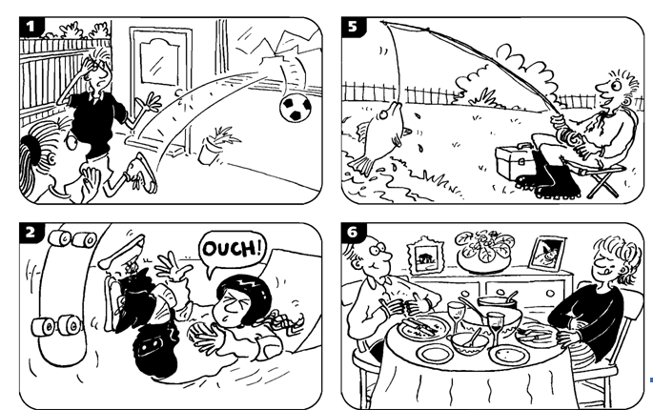

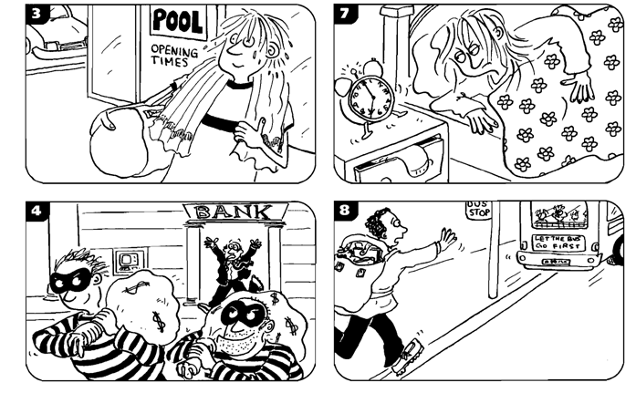

- THEY’VE JUST BROKEN A WINDOW.
- SHE’S JUST FALLEN OFF HER SKATEBOARD.
- HE’S JUST BEEN SWIMMING.
- THEY’VE JUST ROBBED A BANK
- HE’S JUST CAUGHT A FISH.
- THEY’VE JUST FINISH THE DINNER.
- SHE’S JUST WOKEN UP.
- HE’S JUST MISSED THE BUS

- Look at the pictures in exercise 1 and answer the questions.

Picture  1.Have the broken the window? Yes, they have.  2. Has she fallen oof her bike? No, she hasn’t.  3. Has he been to the shops? No, he hasn’t.  4. have they robbed the bank?Yes, they have.  5. has he caught a mouse? No, he hasn’t.  6. have they just started the dinner? No, they haven’t.  7. has she just woken up?.yes, she has.  8. Has the bus left the bus stop? Yes, it has. | 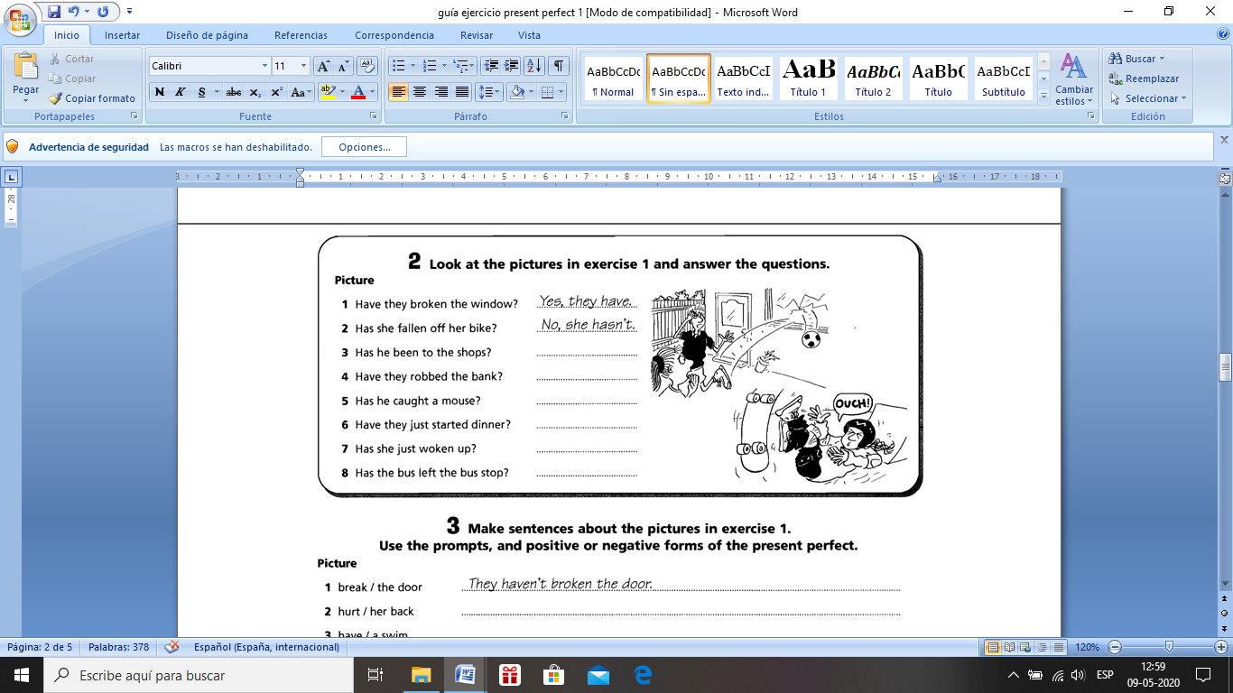

- Make sentences about the pictures in exercise 1. Use the prompts, and positive or negative forms of the present perfect.

Picture
- break/the door …… They haven’t broken the door
- hurt /her back She’s hurt her back
- have/ a swim He’s had a swim
- steal/ a car They haven’t stolen a car.
- drop /the fish He hasn’t dropped a fish.
- eat / all their food They’ve eaten all their food.
- brush/ her hair She hasn’t brushed her hair.
- miss/ bus He’s missed the bus.

Already, yet, for, since

- Look at the pictures. Make sentences with already or yet and the present perfect.

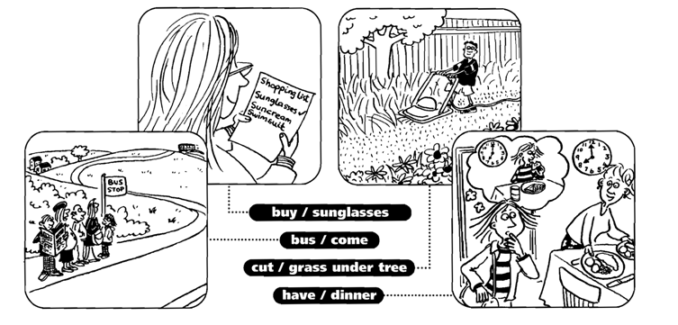

- e.g. She’s already bought some sunglasses.
- The bus hasn’t come yet.
- He hasn’t cut the grass under the tree yet.
- The daughter’s already had dinner.

- Look at the pictures in exercises 1 . Complete the questions and answers.

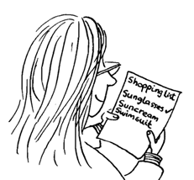 | - Has she bought any suncream yet?  No, she hasn’t. She’s going to buy some later.  - Have the passengers got on the bus yet?  No, the passengers haven’t got on the bus yet.  - Has he cut the grass near the flowers yet?  Yes, he’s already cut the grass near the flowers.

- Look at the pictures. Make sentences with for and since and the Present perfect of these verbs.

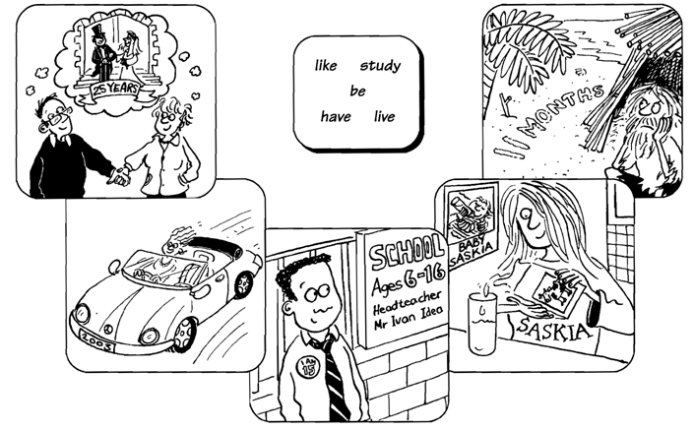

- They ‘ve been married for 25 years.
- She’s had the car since 2003.
- He’s studied at the same school since he was six.
- She’s liked milk since she was a baby.
- He’s lived on the island for 11 months.

- And you? Answer these questions: (YOUR OWN ANSWERS)

- Have you finished these exercises yet?
……………………………………………………………………………………………………….

- Have you had breakfast yet?
……………………………………………………………………………………………………….

- How long have you been at your school?
……………………………………………………………………………………………………….

- Have you always lived in the town where you lived now?
……………………………………………………………………………………………………….

- How long have you had the shoes that you’re wearing?
……………………………………………………………………………………………………….

Speaking

- Write questions using ever. Then ask your partner, your father or your mother or some relative these questions, and write short answers.

# | Use These Words | Question | Short Answer
Ex | go / cruise | Have you ever gone on a cruise? | Yes, she has.
1 | travel / another country | Have you travelled to another country?
2 | walk / through the jungle | Have you ever walked through the jungle?
3 | go / whitewater rafting | Have you ever gone whitewater rafting?
4 | fly / across an ocean | Have you ever flown across an ocean?
5 | travel / across the USA | Have you ever travelled across the USA?
6 | visit / a temple in Japan | Have you ever visited a temple in Japan?
7 | be / Hawaii | Have you ever been to Hawaii?
8 | live / another country | Have you ever lived in another country?
9 | see / Eiffel Tower | Have you ever seen the Eiffel Tower?

Writing

- Write a short paragraph about your partner using the information you learned in Part A. Use never in some of your sentences.

Example:
My partner has travelled across the USA, but she’s never been to Hawaii.

Answer will vary.

