**Guía Evaluada**

**Name: _____________________________________ Date: _____________ Class: 7th ___**

**_____________________________________**

**OA:** Reconocer y aplicar vocabulario y gramática correspondiente a contenidos de 5° y 6° básico a distintos contextos.

|  |
| --- |
| **Instrucciones :**   * Antes de contestar esta guía evaluada debe estudiar y desarrollar todas las guías   enviadas y ver los videos para su aprendizaje.   * Esta guía evaluada tiene 40 puntos. * No se revisarán guías que no estén escritas en inglés.      * Trabaje individualmente o en pareja. Más de 2 estudiantes la guía no será corregida.   Si elige trabajar en pareja podrá utilizar distintas plataformas de conectividad como por ejemplo realizar la evaluación en Drive de gmail, videollamadas por whatsapp, Zoom u otra plataforma que les permita organizar el trabajo.   * La fecha de entrega se **publicará** en un calendario de evaluaciones del nivel en la página institucional (www.liceo1.k12.cl) * Debe enviar su guía en **formato word** al buzón de tarea de su respectivo profesor(a) de la asignatura, a través de la página institucional (www.liceo1.k12.cl), ingresando a Liceo 1 virtual. * Si la guía no se presenta , luego de dos días posterior a la fecha de entrega, se   aplicará reglamento de evaluación.  **Es muy importante que no olvide poner su nombre y curso para que no existan confusiones**  **en la revisión de su guía.** |

**VERB TO BE**

I. Put the words in the right order. (5 points)

**Example**

0) am / I / student / a

|  |
| --- |
| I am a student |

1) a / student / is / Mary

|  |
| --- |
|  |

2) happy / are / we / ?

|  |
| --- |
|  |

3) not / my brother / Tim / is

|  |
| --- |
|  |

4) David and Sue / not / are / late

|  |
| --- |
|  |

5) he / a / ? / painter / is /

|  |
| --- |
|  |

**II. Make questions for these answers**. (5 points)

**Example**

|  |
| --- |
| 0. Are uou Spanish ? |

No, I’m not Spanish. I’m Australian.

|  |
| --- |
| 1. ? |

Yes, they are my friends.

|  |
| --- |
| 2. ? |

No, we aren’t brother and sister.

|  |
| --- |
| 3. ? |

Yes, she is new here.

|  |
| --- |
| 4. ? |

No, they aren’t happy.

|  |
| --- |
| 5. ? |

Yes, Alice is in the living room.

III. Complete with **am, is, are, am not, isn’t** or **aren’t.** (10 points)

|  |
| --- |
| Imagen relacionada  Hello! I Ruby. I ____________ an only child because I have a brother: Daniel. We go to the same school but we ____________________ in the same class. He _________ eight and I _________ twelve.  We have a dog. Her name _________ Polly. Right now, we __________ in the dining room but Polly__________ with us. She _________sleeping in the kitchen. It _____ warm and sunny today we will take her for a walk later. |

**DAYS OF THE WEEK AND MONTHS OF THE YEAR**

IV. Answer the following questions. (8 points)

**Example:** 0. What day is before Saturday? ______Friday______________

1. What day is after Wednesday? __________________________

2. What day is after Sunday? _____________________________

3. What month is this month? ____________________________

4. What month is next month? ___________________________

5. When is your birthday? ______________________________

6. What is the first month? _____________________________

7. What is the twelfth month? ____________________________

8. What is your favourite day? ___________________________

**THIS – THAT – THESE – THOSE**

V. Use this, that, these, those and correct form of verb to be. (5 points)

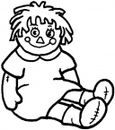 This is a doll.

1. **______**  **_______** my boots



2. .



3. . .

4. . __. is my ball.  

5. _______ ______

**Possessive and family members**

VI. Look at the family tree and complete the sentences. (7 points)

**Family Tree**

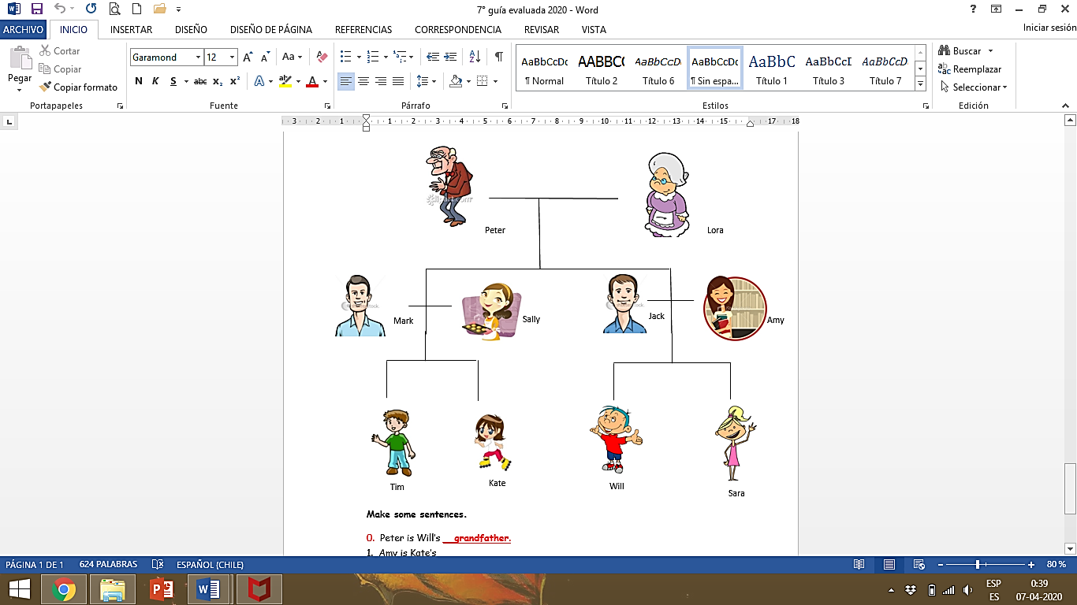

0. Peter is Will’s **__grandfather**.

1. Amy is Kate’s __________________

2. Lora is Kate’s __________________

3. Jack is Sara’s __________________

4. Sally is Tim’s ___________________

5. Will is Sara’s __________________

6. Mark is Will’s __________________

7. Tim is Sara’s __________________

**GOOD LUCK!**