***Liceo Nª1 “Javiera Carrera” –Santiago***

*126 años al servicio de la Educación Pública (1894-2020) English Department*

*Miss Camila Pizarro F. / Miss Evelyn Villarroel J.*

HANDOUT N° 4

**Are you happy? A rap**

**Name: Class: 7th_ Date: OA**: Identificar palabras y frases clave, expresiones de uso frecuente, vocabulario temático. Reaccionar a textos leídos y escuchados.

**Instructions**: Write the words, under each picture. Listen to the song and circle the correct words. sing!

**Time**: 20 minutes

# Write the words under each picture

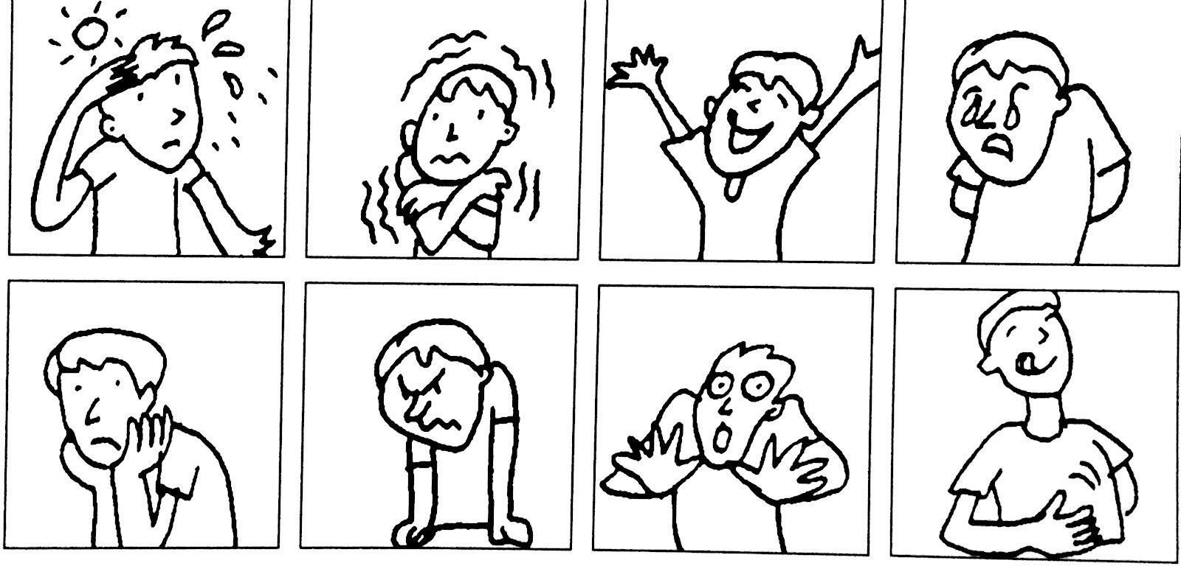

hungry – scared – angry – bored – sad – happy – cold – hot

**Are you happy?**

1. **Listen and circle the correct words. Sing!**

|  |  |
| --- | --- |
| Ice cream, ice cream  Give the kids some ice cream - They’re hot  Yeeehhh Mmmmmm Oooooohh  Are you ***happy / sad***? No, I’m not.  Are you ***hot / cold***? No, I’m ***hot / cold***  Is she ***sad / happy***? No, she’s not.  Is she ***hot / cold***? No, she’s ***cold / hot*** | Is he ***scared / happy***? No, he’s not.  Is he ***angry / cold***? No, he’s ***sad / hot***  Are you ***hungry / happy***? No, we’re not  Are you ***bored / cold***? No, we ***hot / sad***  Are they ***scared / happy***? No, they’re not.  Are they ***cold / bored***? No, they’re ***hot / angry***  Ice cream, ice cream  Give the kids some ice cream -  They’re hot  (let’s ask the question again) (repeat to end) |

**“*Oh, humanos, la gloria culmina en el corazón de la mujer”*** *Compañía de Jesús Nº 1484*

## Fono: 26964714-26968097 e-mai[l: direccion@liceo1.cl](mailto:direccion@liceo1.cl)

*RBD: 8487-5*

ANSWERS

1.

1. hot

2. cold

3. happy

4. sad

5. bored

6. angry

7. scared

8. hungry

2.

happy

cold

hot