HANDOUT N° 3

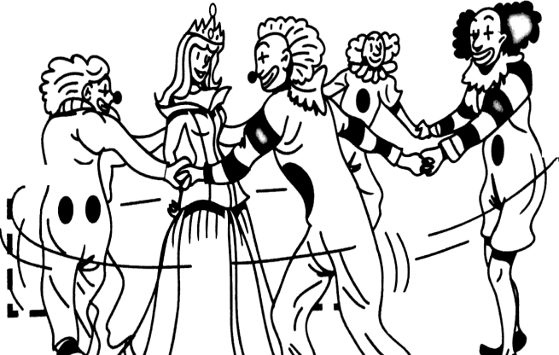

# Song: To be party

**Name: Class: 7th ___ Date:**

**OA**: Identificar palabras y frases clave, expresiones de uso frecuente, vocabulario temático. Identificar verbo to be.

**Instructions**: Sing the song and match and write the numbers next to the sentences.

**Time**: 30 minutes

|  |  |
| --- | --- |
| a.  I’m the sheriff You’re the clown He’s a cowboy Please sit down  Clap clap, now you rap  b.  I’m the sheriff You’re the clown He’s a cowboy Please sit down  Clap clap, now you rap  a.  She’s a princess, It’s great fun, Clap your hands Everyone  Clap, clap, now you rap!  b.  She’s a princess, It’s great fun, Clap your hands Everyone  Clap, clap, now you rap! | a.  We’re so happy, You’re so cool  There’s a party at our school Clap clap, now you rap!  b.  We’re so happy, You’re so cool  There’s a party at our school Clap clap, now you rap!  a.  Lots of girls Lots of boys  They’re so loud – what a noise  Clap, clap now you rap  b.  Lots of girls Lots of boys  They’re so loud – what a noise  Wooooooo (Ssssssshhhh! Quiet everyone:  And now really fast – here we go!  **(repeat rap)**  (Woooooooo!  And now even faster) (**Repeat rap)** |

**Activity**

**Match and write the numbers**

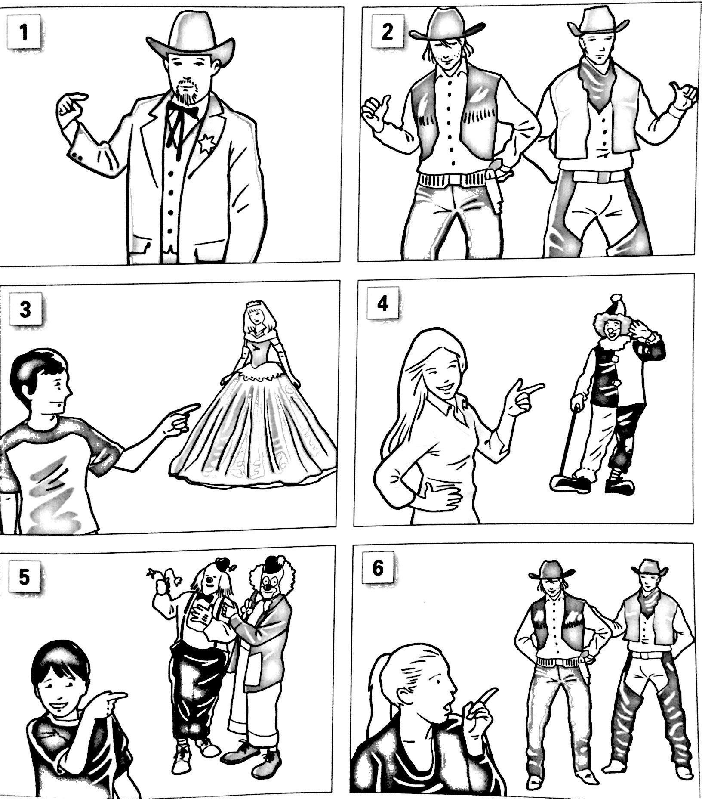

|  |  |  |
| --- | --- | --- |
| We’re cowboys | They’re cowboys | He’s a clown |
| She’s a princess | I’m a sheriff | They’re clowns |

ANSWERS

Activity

2 6 4

3 1 5