# HANDOUT N° 2 : Verb to be

Name: Date: Class : 7th

|  |  |  |  |  |
| --- | --- | --- | --- | --- |
|  | OA: Demostrar comprensión de ideas generales e información explícita en textos  adaptados y auténticos simples, en formato impreso o digital, acerca de temas variados (como experiencias personales, temas de otras asignaturas, del contexto inmediato, de  actualidad e interés global o de otras culturas) y que contienen las funciones del año. | | | |
| Instructions :  *Work individually or in pairs.  *Time : 4 hours | | |  |
| **Affirmative – short form** | | **Negative – short form** | **Interrogative** | |
| I am → I’m | | I am not → I’m not | Am I? |  |
| You are → You’re | | You are not→ You aren’t | Are you? |  |
| We are → We’re | | We are not → We aren’t | Are we? |  |
| They are → They’re | | They are not →They | Are they? |  |
| He is → He’s | | aren’t | Is he? |  |
| She is → She’s | | He is not → He isn’t | Is she? |  |
| It is → It’s | | She is not → She isn’t | Is it? |  |
|  | | It is not → It isn’t |  |  |

**Write the Verb to be and change to short form.**

1. I →

2. you → 3. We →

1. They →

5. He →

1. She →

7. It →

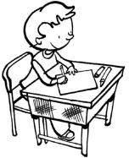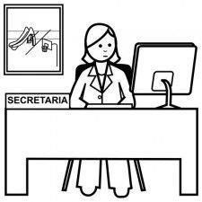

|  |  |
| --- | --- |
| **Look at the pictures and answer the question**   1. Is he a teacher? No, he is not._ _ 2. Is it an elephant? 3. Is it a pencil? 4. Are they twins? 5. Is he in the park? 6. Is he a painter? 7. Is Ricky in the living room? 8. Is mom in the kitchen? | 1. 2. 3.  4 .  5. 6.  7.  8. |

|  |  |
| --- | --- |
| **Write the correct Verb to be (+)**   1. Cindy my best friend. 2. Peter and Kate classmates. 3. Johnny my brother. 4. You a good student. 5. They in the classroom. 6. It an apple. 7. Felicia and I sisters. 8. I her teacher. 9. It a book bag. 10. You a doctor. | **Re-arrange the sentence.**   1. I / not / a teacher / am 2. she / my mother / is      1. the boys / playful / are 2. the girl / in the room / is 3. we / not / are / at home   6. my dad / smart / is  7. my mother / a housewife / is  8. she / not / my sister / is  9. the teacher / angry / is  10. the dog / in the kennel / is |

# Reading:

**1.- Read the texts.**



Alberto

Hi, my name is Alberto and this is my family tree. This is my mother; her name is Rosa and she is beautiful. My mother works as a

nurse. I’m an only child. I have no brothers or sisters, but I live with my cousin Cristian, my aunt Maria’s son. He is like my brother. They

are my grandparents. She is my grandmother, Matilde, and he is my grandpa, Ernesto. We live in the same house in Sydney!

Patricia

This is my family tree. My name is Patricia and she is my mom, Gloria, she is an engineer. My dad’s name is Fernando and they are married. I have two sisters and one brother. I’m the youngest.

They are Uncle Thomas and Aunt Kathleen. They have two daughters, Megan and Sharon. They all live in the USA. They are my mom’s parents, Juan and Teresa, my grandma and grandpa. They live in Coquimbo.

**2.- Decide if these statements are true (T) or false (F).**

* 1. The mother of Patricia is an engineer.
  2. Alberto lives in London.
  3. Rosa is a nurse
  4. Juan and Teresa are Patricia’s grandparents.
  5. Patricia’s grandparents live in Sydney.
  6. Matilde is Alberto’s grandmother.
  7. Alberto has two sisters.
  8. Fernando and Gloria are married.

**3.- Complete the sentences with *am, is* or *are*.**

1. They *are* brothers.
2. He Mark.
3. You my best friend.
4. Susan my sister.
5. I a good student.
6. Mark and Susan twins.
7. Mr. Juan a perfect teacher.
8. They scientists.
9. We cousins.
10. This my dog Firulais.

4 .- Complete the sentences as the example.

1. They *are* doctors. (✓) 6. They *aren´t* singers. (✗)

2. I number three. (✓) 7. I number two. (✗)

3. He thirteen years old. (✓) 8. He twelve years old. (✗)

4. You nice. (✓) 9.You ___stupid. (✗)

5. We from Portugal. (✓) 10. We from France. (✗)

1. - Put the words in the correct order.
   1. am / I / a / teacher → *I am a teacher.*
   2. not / an / engineer / he / is →
   3. doctor / are / you / ? / a →
   4. is / good / this / book / very →
   5. in / the / are / ? / you / garden→ _

6.- Complete the questions with the correct form of verb “to be”, then answer the questions. Follow the example.

1. *Are* you a boy?
   1. No, I am not. b) No, she isn’t. c) Yes, they are. d) Yes, she is
2. she Portuguese?
   1. No, she isn’t. b) Yes, they are. c) Yes, you are. d) No, they aren’t
3. you twelve?
   1. Yes, she isn’t. b) Yes, they are. c) Yes, I am. d) No, they aren’t
4. it nine o´clock?
   1. Yes, it is. b) No, they aren’t. c) Yes, she is. d) No, she isn’t
5. your father tall?
   1. No, she isn’t. b) Yes, he is. c) No, they aren’t. d) Yes, she is

# II. Activity : work in pairs. Ask and answer, using short answers.

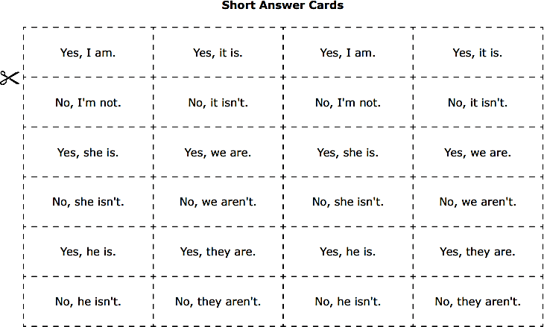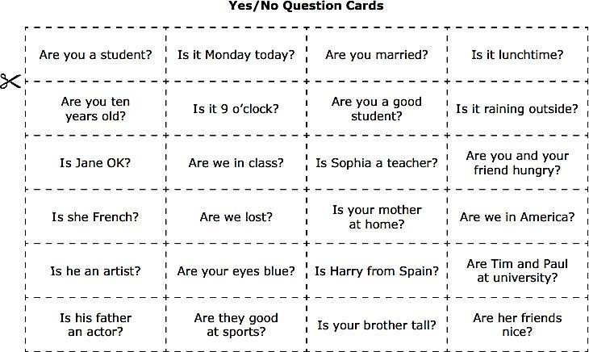

**ANSWERS**

Write the verb to be and change to short form.

1. I am - I’m

2. You are - you’re

3. We are - We’re

4. They are - They’re

5. He is - He’s

6. She is - She’s

7. It is - It’s

Look at the picture and answer the question.

2. Yes, it is.

3. Yes, it is.

4. Yes, they are.

5. No, he is not.

6. Yes, he is.

7. No, he is not.

8. No, she is not.

Write in the correct Verb to be.

1. is

2. are

3. is

4. are

5. are

6. is

7. are

8. am

9. is

10. are

Re-arrange the sentence.

1. I am not a teacher. 6. My dad is smart.

2. She is my mother. 7. My mother is a housewife.

3. The boys are playful. 8. She is not my sister.

4. The girl is in the room. 9. The teacher is angry.

5. We are not at home. 10. The dog is in the kennel.

Reading

2. a. True

b. False

c. True

d. True

e. False

f. True

g. False

h. True

3. b) is

c) are

d) is

e) am

f) are

g) is

h) are

i) are

j) is

4. 2. am 7 . am not

3. is 8. isn’t

4. are 9. aren’t

5. are 10. aren’t

5. 2. He is not an engineer.

3. Are you a doctor?

4. This book is very good.

5. Are you in the garden?

6. 2. Is

a)

3. Are

c)

4. Is

a)

5. Is

b)