**Unit 1 – Handout 1 - Information and Communication Technologies**

**Instructions:** Follow the instructions given in each item. Work individually or with the help of your classmates.

**Time:** 90 minutes

**OA:** Demostrar comprensión de ideas generales e información explícita en textos orales adaptados… Identificar palabras y frases clave, expresiones de uso frecuente, vocabulario temático… Reaccionar a textos leídos…

**Name: ____________________________________ Class: 8th ___ Date: ____________________**

**PART 1 – Reading**

 **Watch the video and answer the following questions:**

1. Where is your phone right now? _________________________________________________
2. Where is your phone when you sleep? ____________________________________________
3. Do you use your phone to check the time? _________________________________________
4. Do you take your phone into the bathroom with you? ___________________________________
5. Do you call or text someone in the same house as you? _______________________________
6. Do you use your phone in the middle of the night? __________________________________
7. Do you have your phone when you are eating? _____________________________________

|  |
| --- |
| **What is ICT?**  It stands for "Information and Communication Technologies." ICT refers to technologies that give access to information through telecommunications. It is similar to Information Technology (IT), but focuses principally on **communication**. This includes the Internet, **wireless** networks, cell phones, and other communication mediums.  Resultado de imagen para ict.png  Thanks to information and communication technologies, people can **communicate** in real-time with others in different **countries** using technologies such as instant messaging and video-conferencing. Social networking websites like Facebook and Instagram allow users from all over the world to share pictures and information, principally with their **mobile phones** which are more important than personal computers today.  Modern information and communication technologies have created a "global village," in which people can communicate with others across the world as if they were living next door. For this reason, ICT is often studied in the context of how modern communication technologies affect society. For example, teachers can interact with their students, this is good to improve education. |

**1. Answer the questions:**

1. Does ICT include cell phones?

______________________________________________________________________________

1. Do people prefer their mobile phones over computers today?

______________________________________________________________________________

1. Name 3 advantages of ICT in society

_________________________________

_________________________________

_________________________________

**2. Match the words with their examples:**

1. Communication (n)
2. Communicate (v)
3. Wireless (adj)
4. Country (n)
5. Mobile phone (n)
6. The climate is cooler in the east of the ________________.
7. We can now __________________ instantly with people on the other side of the world.
8. With no decent phone signal, _________________ is difficult.
9. Sometimes we spend money on things we don’t really need: an expensive ________________________, or the biggest TV screen.
10. Today, there are a large number of ____________ headphone options that use Bluetooth to connect to your smartphone.

**3. Vocabulary – Write the devices next to the actions**

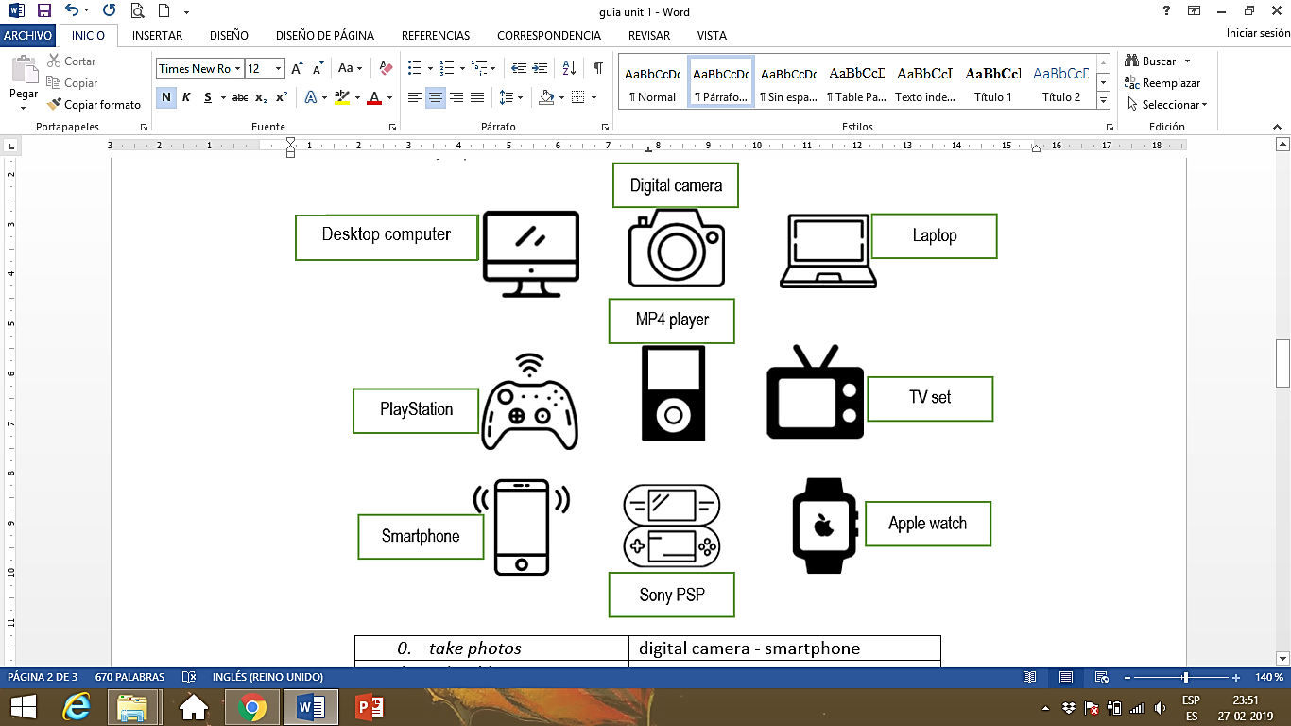

|  |  |
| --- | --- |
| ***example****: take photos* | digital camera - smartphone |
| 1. *take videos* |  |
| 1. *make phone calls* |  |
| 1. *play games* |  |
| 1. *surf the internet* |  |
| 1. *listen to music* |  |
| 1. *send emails* |  |
| 1. *download music* |  |
| 1. *watch DVDs* |  |
| 1. *send text messages* |  |

# Complete the names of the technological devices in the sentences

1. You can take photos with a d_g_t_l c_m_r_.
2. You can make phone calls, take videos and send text messages on a s_art_h_n_
3. You can surf the internet on a p_rs_n_l co_pu_er
4. You can play games on a P_a_S_a_i_n.
5. You can send emails on a l_pt_p computer.
6. You can listen to music on an MP4 _l_y_r

**PART 2: Grammar: Look at the chart – Expressing preferences – to talk about likes and dislikes**

|  |  |  |
| --- | --- | --- |
|  | **X** | **XX** |
| **like / love / enjoy + verb (ing)** | **don’t like + verb (ing)** | **hate + verb (ing)** |
|  |  | **can’t stand + verb (ing)** |

1. **Choose your true option**

1. I *like / don’t like* downloading music

2. I *enjoy / hate* playing football games on a PlayStation.

3. I *hate / love* making calls with my Smartphone

4. I *can’t stand / enjoy* sending text messages to my friends

5. I *love / hate* watching Netflix on my laptop.

6. I *can’t stand / like* listening to music on an MP4 player

1. **Complete the sentences with the correct form of the verbs**

|  |
| --- |
| get up – go – have – ~~play~~ – read – speak – watch – work |

1. I hate playing video games. They’re boring
2. My mum can’t stand ___________________ sport on TV
3. My friends and I love ___________________to the cinema at the weekend
4. My grandad enjoys ___________________ in the garden
5. I can’t stand ___________________ fantasy books
6. Do you like ___________________ English?
7. My parents don’t like ___________________ early on Saturdays
8. My brother doesn’t like ___________________ a bath. He always has a shower.
9. **SPEAKING**

You have four minutes to make a list of four things that you really like doing with your mobile phone and four that you hate doing.

|  |  |
| --- | --- |
| Like doing | Hate doing |

Language Focus: Expressing Preference - page 24 from the Student’s book

1. **Match words from A and B. Then, listen and check.**

|  |  |  |  |
| --- | --- | --- | --- |
| A   1. digital ______ 2. internet _____ 3. mobile _____ 4. online ______ 5. phone ______ | 1. social ______ 2. text ______ 3. video ______ 4. web ______ | B   1. access 2. call 3. camera 4. clip 5. dating | 1. message 2. network 3. page 4. phone |

1. We don’t get very good ___________________________ where I live in the country
2. I met my husband through an ___________________________ website
3. I think Facebook is a fantastic ___________________________
4. Please send me a ___________________________ to tell me where to meet you
5. Did you see that funny ___________________________ of the cats talking?

**KEY**

**PART 1 – Reading**

**1 to 7: personal responses.**

**Possible answers:**

1. My phone is next to me, on the table, in my bedroom, etc.
2. When I sleep, my phone is on the night table, etc.
3. Yes, I do. / No, I don’t.
4. Yes, all the time. / No, never.
5. Yes, I do. / No, I don’t. / I always send memes to my sister / etc.
6. Yes, when I can’t sleep. / No, I never do that.
7. Yes. I check Instagram all the time / No, my parents don’t allow me to do that. / Etc.

**1. Answer the questions:**

1. Yes, it does.
2. Yes, they do
3. 1. People can communicate in real-time with others in different countries. 2. People can share pictures and information. 3. Teachers can interact with their students.

**2. Match the words with their examples:**

a) country

b) communicate

c) communication

d) mobile phone

e) wireless

|  |
| --- |
| *digital camera - smartphone* |
| smartphone– digital camera |
| smartphone |
| smartphone – PlayStation –laptop – desktop computer – Sony PSP |
| smartphone – desktop computer – laptop |
| Mp4 player – smartphone |
| laptop – desktop computer – smartphone |
| desktop computer – laptop |
| TV set – desktop computer - laptop |
| smartphone |

3)

**You can add other devices

**4. Complete the names of the technological devices in the sentences**

1. digital camera

2. smartphone

3. personal computer

4.Play Station

5.laptop

6.player

**PART 2 –**

1. Your personal options

**2. Complete the sentences with the correct form of the verbs**

1) watching

2) going

3) working

4) reading

5) speaking

6) getting up

7) having

**3. SPEAKING – Your personal answers. Examples:**

|  |  |
| --- | --- |
| I like playing games  I like surfing the net  I like uploading stories on Instagram | I hate using the calculator |

**4.** **Match words from A and B. Then, listen and check.**

|  |  |
| --- | --- |
| 1. camera 2. access 3. phone 4. dating 5. call | 1. network 2. message 3. clip 4. page |

1. internet access
2. online dating
3. social network
4. text message
5. video clip